***Ref No: NSCDC/NHQ/APT/2019/1***

**31st January, 2022**

**JOHN DOE**

**RIVERS**

Sir/Madam

**PROVISIONAL OFFER OF APPOINTMENT**

I am directed to refer to your recent application for employment and pleased to inform you that you have been offered appointment as follows:

1. Rank: **CORPS ASSISTANT II**
2. Nature of Appointment: **GENERAL DUTY**
3. Salary Grade Level/Step: **4 Step 2**
4. Basic Salary **N615,081.60** (per annum)

2. Your appointment is subject to the Conditions of Service of **the Nigeria Security and Civil Defence Corps**, the **Public Service Rules and Other Regulations** of the **Civil Defence, Correctional, Fire and Immigration Services Board (CDCFIB)**

3. Your appointment may be confirmed after passing the appropriate confirmation examination and two years of satisfactory service.

4. Your appointment may be terminated at any time by the **Nigeria Security and Civil Defence Corps** or the Board of **Civil Defence, Correctional, Fire and Immigration Services Board** or yourself by giving a month notice in writing.

5. You are required to inform this office in writing if you accept this offer within two weeks from the date of this letter, failing which the offer will lapse.

6. For regularization of your appointment, you are expected to tender for sighting, originals of your credentials.

7. ***Congratulations!!!***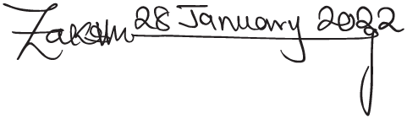







**ZAKARI IBRAHIM NINGI, fdc**

Ag. Deputy Commandant General (Administration)

For: Commandant General